Generating GRANTS for Oracle:

The model:

- Create UDPs at the Table Level as follows:
MyUser is needed only if there is no Owner for the Tables or is a different value.
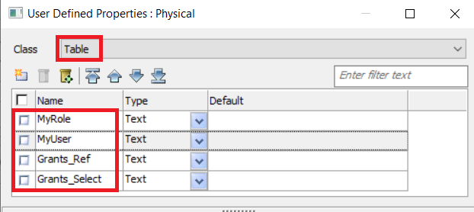

- Add the Values for UDPs in the Tables as needed.
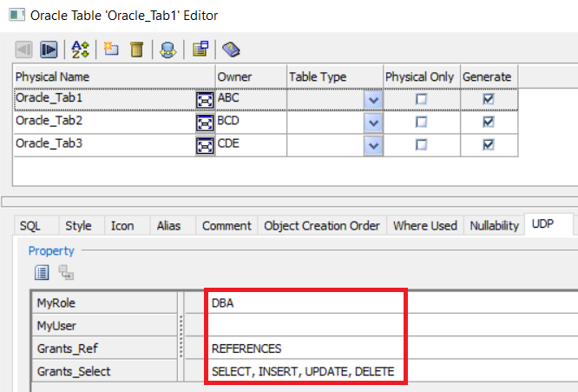

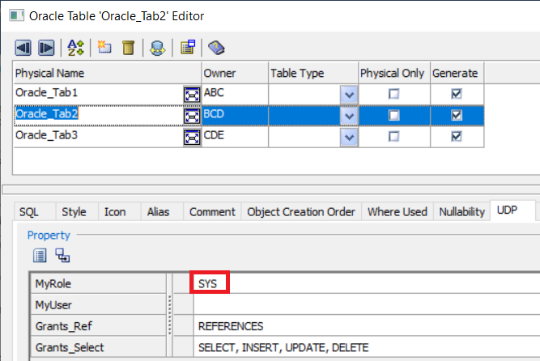

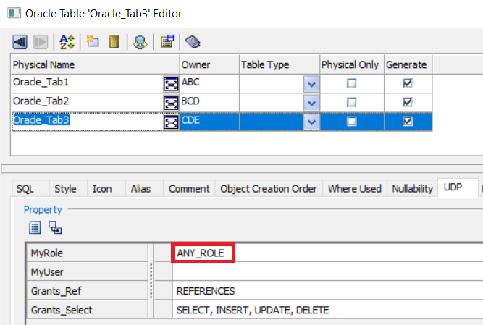

- Create Scripts as needed – these should be at Post Creation level as the syntax should be generated after the Tables are created:
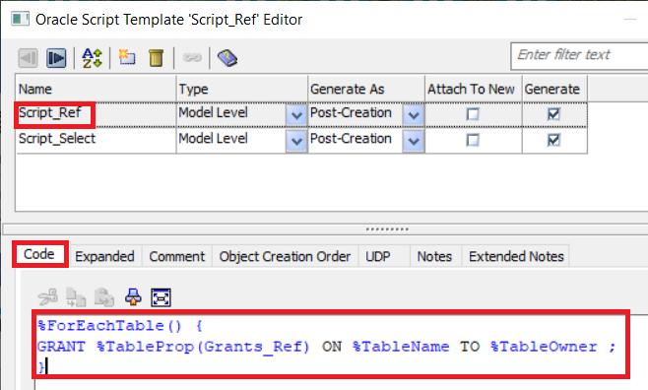

Expanded Script:
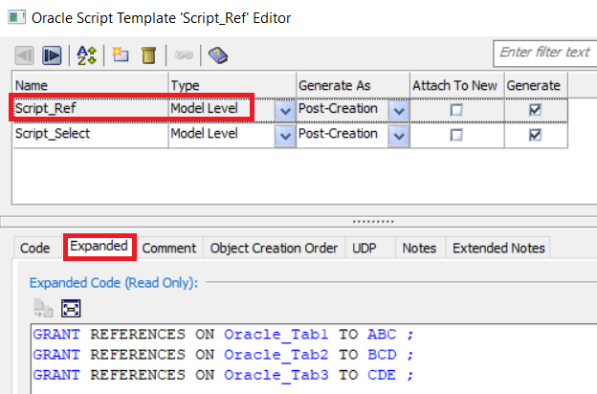

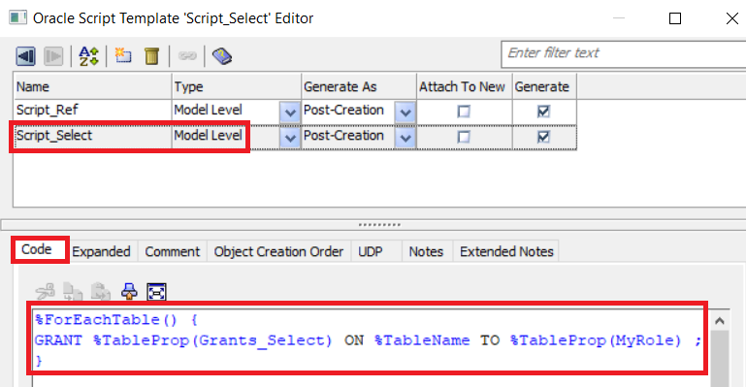

Expanded Script:

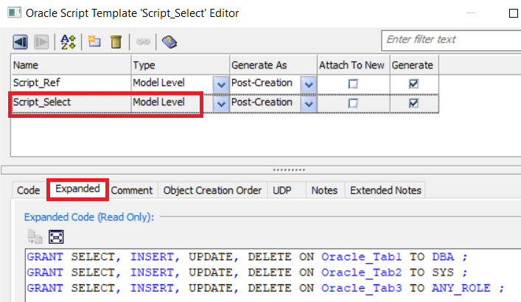

- In Forward Engineering, select Model level Post-Script as follows:

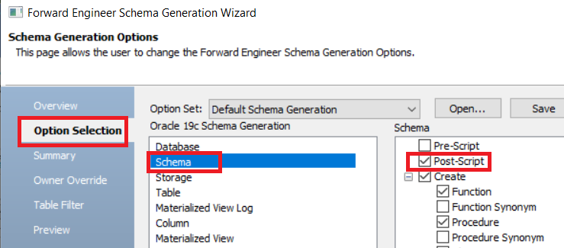

Resultant Script in Forward Engineering Preview:

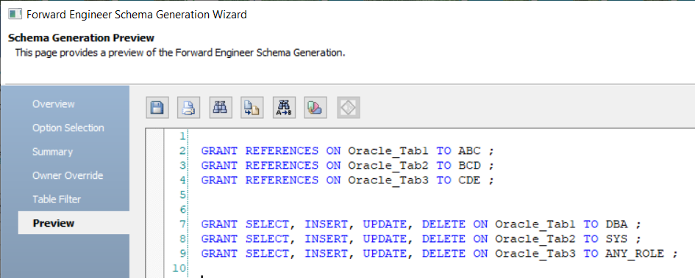

In the scenario above there are two scenarios as follows:

- The GRANT ‘REFERENCES’ is granted for each Table ( %ForEachTable() ) on Table Name (%TableName) to Table Owner (%Table Owner) which requires only one UDP (Grants_Ref)
%ForEachTable() {
GRANT %TableProp(Grants_Ref) on %TableName to %TableOwner
} ;
- The GRANT ‘SELECT, INSERT, UPDATE, DELETE’ are granted to a Role assigned to a Table via another UDP (MyRole) which picks up a Role rather than the Table Owner. This requires two UDPs – one for the GRANTS and one for the Role:
%ForEachTable() {
GRANT %TableProp(Grants_Select) on %TableName to %TableProp(MyRole)
} ;
Using this example one can create as many scripts to generate the GRANTS syntax for as many users and as many Roles as needed. This one is specific to Oracle. If you need to add grants to multiple roles, you will do need to create additional UDPs for each role.

